**Manual to setup tools and code Racing AI program**

**Introduction:**  
This document shows a way to code the racing AI program.

+ First, it shows how to download and install JDK and Eclipse Java developer.

+ Second, it introduces the rules of Racing AI Coding and how to write an AI program

**Download:**

* JDK (<http://www.oracle.com/technetwork/java/javase/downloads/index.html> - free)
* Eclipse (<http://www.eclipse.org/downloads/> - free)

**Note:**

* We have many Java Developer tools such as [Eclipse](http://www.eclipse.org/downloads/), [NetBeans](http://netbeans.org/), [Jcreator](http://www.jcreator.org/download.htm). But is you use Eclipse, you need to download and install *"Eclipse IDE for Java EE Developers*" version to code the racing AI program.

**How to install:**

**JDK:**

Install the JDK by doing the following:

* Downloading the Installer
* Running the JDK Installer
* Installing the JDK Silently
* Updating the PATH Variable (Optional)
  + To set the PATH variable permanently, add the full path of the jdk1.7.0\bin directory to the PATH variable. Typically, this full path looks something like C:\Program Files\Java\jdk1.7.0\bin. Set the PATH variable as follows on Microsoft Windows
    - Click Start, then Control Panel, then System.
    - Click Advanced, then Environment Variables.
    - Add the location of the bin folder of the JDK installation for the PATH variable in System Variables. The following is a typical value for the PATH variable:
    - C:\WINDOWS\system32;C:\WINDOWS;C:\Program Files\Java\jdk1.7.0\bin
* Starting to Use the JDK

**Eclipse:**

* There is no installer used to install Eclipse. The process described below involves un-archiving (unzipping) a directory tree of files and placing it in an appropriate location on your hard disk.

**Racing AI Coding**

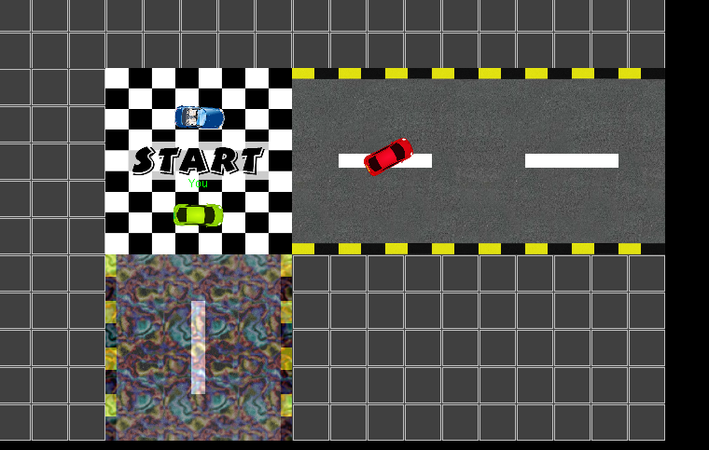

Figure 1 A scene in the racing

**Rules:**

Racing AI Coding is a game combining Car racing and finding the way through the maze. Each AI will control a car to find the way through the maze. It must handle collisions with the wall or other cars, and find the fastest route to goal. Rankings will be calculated based on the finish time of AI.

You need coding your AI to control the car to find the way to goal of a maze. You are not given the map of maze before the race started. Same with real maze, you can get the kind of a block of the map such as wall, road or low speed area if only if your car ran near to that block.

**Racing map:**

The maze map is defined by *n*×*m* blocks. Each block is defined different kinds.

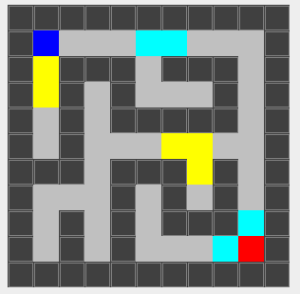

Figure 2 A sample of the map of maze

**The kinds of maze map are defined by some characters as following:**

* Start area (block): defined by character ‘S’

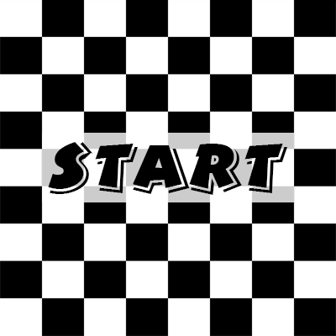

Figure 3 Start area

* Goal area (block): defined by ‘G’. Your car needs to find this area.

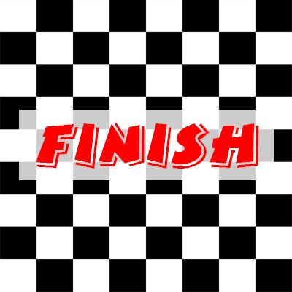

Figure 4 Goal area

* Road area (block) : defined by ‘0’. Your car can run on this area

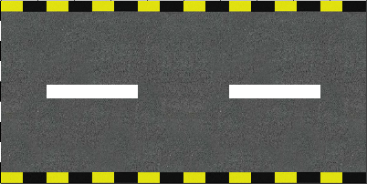

Figure 5 Road area

* Slow area (block): defined by ‘2’. Your car’s speed will be down when your car run on this area.

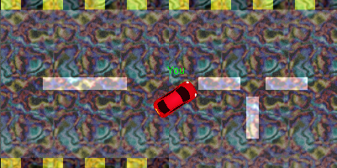

Figure 6 Slow area

* Un-controllable area (block): defined by ‘3’. Your car will turn right if your program controls it to the left and your car will turn left if your program controls it to the right.

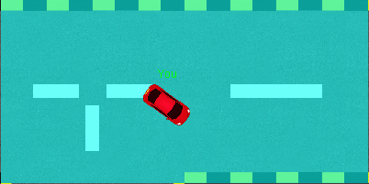

Figure 7 Un-controllable area

* Other area (block):
  + Wall area: defined by ‘1’. Your car can not run on this area.
  + Black area: defined by ‘?’. You do not know the kind of this area.

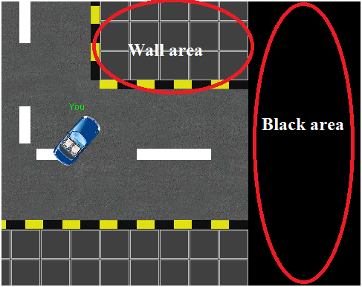

Figure 8 Other area

**Car:**

The size of the car is not fixed and it depends on the number of race cars. If the number of cars is small, the size of the car will be big.

**Mode:**

* There are 2 modes in the game:
  + Having collisions between cars
  + No collisions between cars (Cars will be passing through each other)

**Manual to code Racing AI program.**

* **Step 1:** Import **CarRacingClient** Project to Eclipse:
  + **Eclipse** **🡪 File** 🡪 **Import**:
    - Select **General** -> **Existing Projects into Workspace**
    - Click “**Browse**” at “**Select root directory**”
    - Find folder “**CarRacingClient**” and click “**Finish**”
* **Step 2:** Code AI program
  + Your AI program will be written by you on the file MainAI.java at **RaceAI.AI** package of **CarRacingClient** project.
  + Racing information:
    - You can get the information of the race such maze map size or each block kind from **Race race** object.
    - You can get the information all cars such as size of car or coordinate from **Vector<Car> All_cars** object.
    - And the information of your car can be gotten from **Car Mycar** object.
  + Control your car by change the value of **String key**
    - The **key** is defined by 4 characters.
      * The first character controls your car go up ‘1’ or not ‘0’
      * The second one controls your car go back ‘1’ or not ‘0’
      * The third one controls your car turn left ‘1’ or not ‘0’
      * The 4th one controls your car turn right ‘1’ or not ‘0’



Figure 9 MainAI.java

Note: You are not allowed to change other java files of CarRacingClient.

**How to run:**

You can run your AI program as following:

* **Step 1**: Run file “.\CarRacingServer\RacingAIServer.jar” to start server program. Click “**Start Server**” button. You can set the Port before click the “Start Server”.

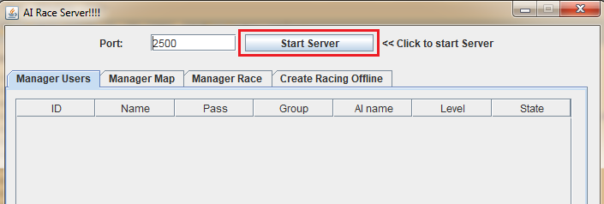

Figure 10 Start server

* **Step 2**: Make the racing room by select the “**Manage Race**” tab.
  + You can set the parameter of the room by select the “**Custom**” and click “**Start Room**” button to allow starting the racing game.

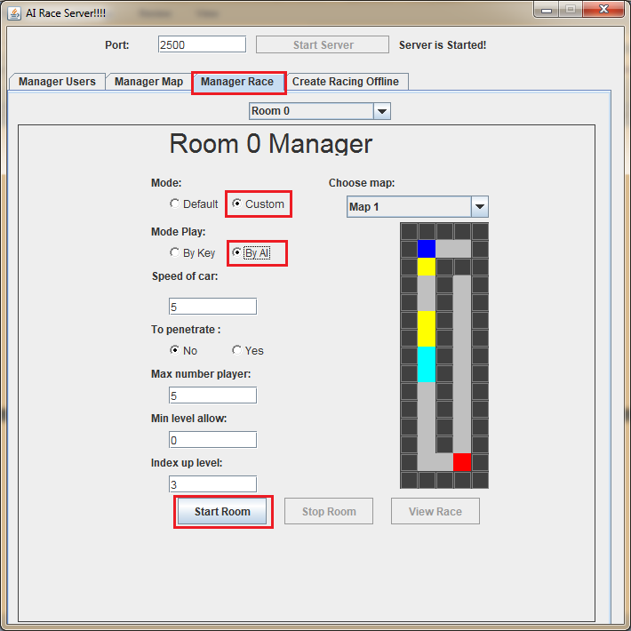

Figure 11Make starting room

* **Step 3**: Run the client:
  + From CarRacingClient project, click right button of your mouse 🡪 “**Run As**” 🡪 **Java Application**

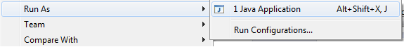

* + The client form will be shown:

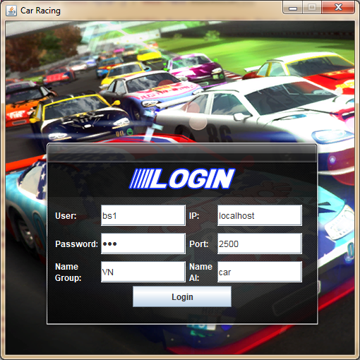

Figure 12 Login form

* + Set User name, password and server address to login
  + Select Racing room and click “**Join**”

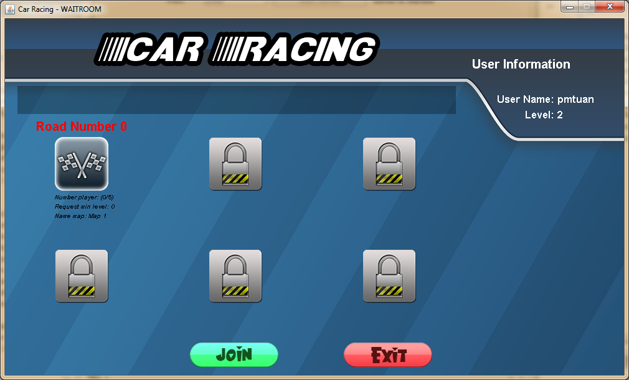

Figure 13 Select Room

* + Wait other AI joining the room and select “**Ready**” button to start the racing.

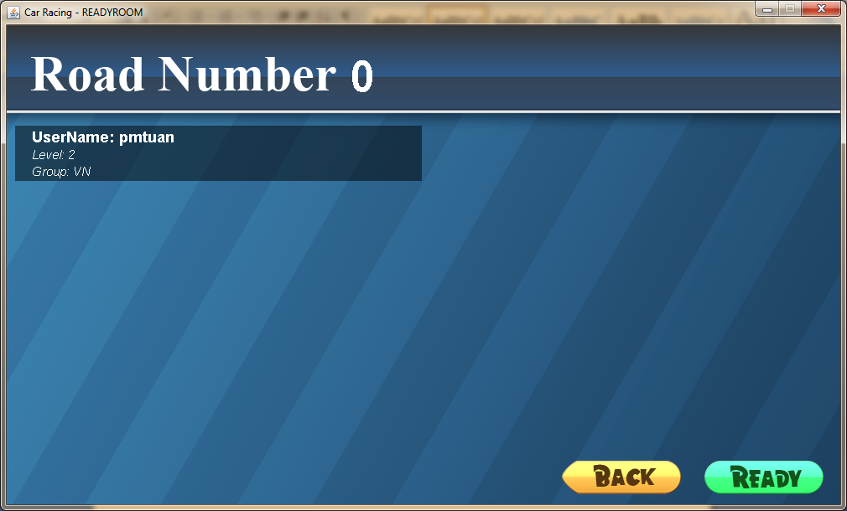

Figure 14 Ready room

* + Your AI will be started via following.

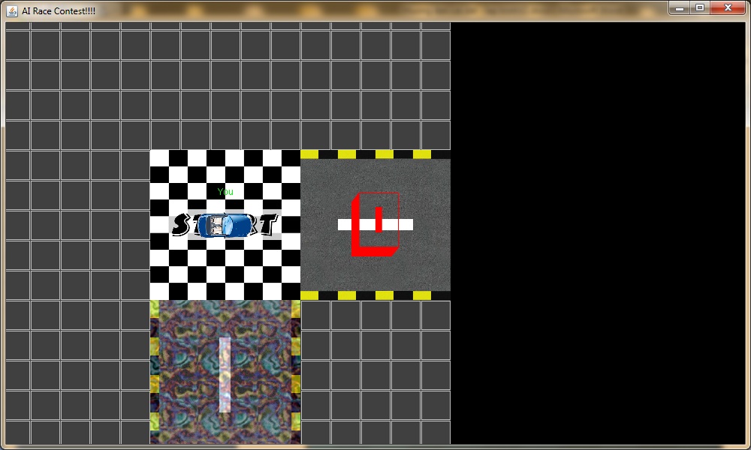

Figure 15 Start AI

**Manage users and maze maps on Server.**

* **Manage Users:** Select “**Manager Users**” to get information of the users
  + Click “**Add User**” button to add user.
  + Click “**Delete Users**” button to remove user.

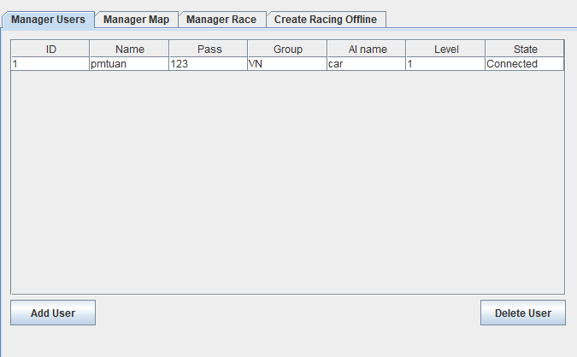

* **Manage Maps:** Select “**Manager Map**” tab to create and save new random map or delete a map.

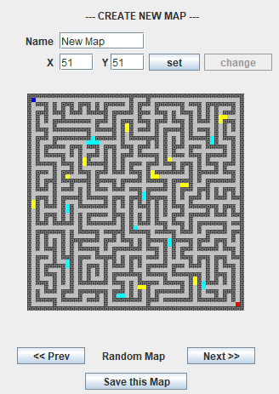

Figure 16 Create new random map

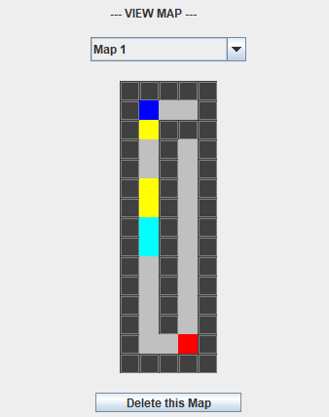

Figure 17 Delete a Map